**TITLE** – add notification field to the email subscription  
  
**DESCRIPTION**:  
**WHY**

It increase level of feedback about specific users actions, namely:  
1. User will be understand which typical mistakes can be:   
 1.1. Wrong email – invalid view (with forbidden symbols);

1.2. Empty field in email field.

2. User successfully subscribed and received appropriate message

3. Email address has already used so user should use another email address

**TODO**

1. Add appropriate field (notification) under email field;
2. Make sure, that size of field not less than size of the biggest message about problem;
3. Make sure, that messages is work when press button SIGNUP.

**CONTENT**

It should be the next messages:

1. If it will be problem with typical mistakes:
   1. Wrong email: “Email is invalid”
   2. Empty field: “This field is required”;
2. Successfully subscribe: “Thank you for your subscription”;
3. Email address has already used: “This email address is already subscribed”.

**VISUALS**

It can be the next way:

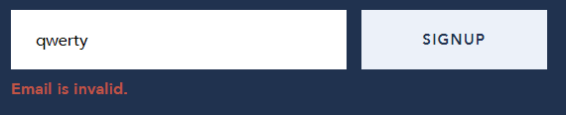

**HOW TO TEST**

Will be assume that email field have already tested. In this case so that check notification field we should:

1. Enter invalid email, press button SIGNUP. For example: qwerty. In this case we receive next message: “Email is invalid”.

2. Leave email field is empty and press button SIGNUP. In this case we receive next message: “This field is required”.

3. Enter correct email address in email field, press button SIGNUP. In this case we receive next message: “Thank you for your subscription”.

4. Enter email address which has already used for subscription. In this case we receive next message: “This email address is already subscribed”.